

King Abdullah || School of Information Technology

student medical services system

|  |  |
| --- | --- |
| Project Team Member | |
| 2200593 | Monia Waleed Samih Dohnon |
| 220041 | Heba Ibrahim Samih Aqil |
| 0203422 | Jumana Aiman Ahmad Mukheimar |
| 0202137 | Yara Feras Omer Al-Rbeihat |

Table of Contents

***1.0 Introduction:*** 6

**1.1 Project Overview** 6

**1.2 The purpose of the Project** 6

**1.3 The Scope of the Work and Project Deliverables** 6

**1.4 Naming Conventions and Definitions** 7

***2.0 Project Management plan*** 8

**2.1 Project Organization** 8

**2.2 Software Process Model** 8

**2.3 Roles and Responsibilities** 8

**2.4 Tools and Techniques** 8

**2.5.n Project Tasks** 9

2.5.n.1 Task Description 9

2.5.n.2 Deliverables and Milestones 9

2.5.n.3 Resources needed (Skills, HW and SW) 10

2.5.n.4 Dependencies and Constraints 11

**2.6 Assigning Team Members to Tasks & 2.7 Project Schedule (Gantt chart and PERT diagram)** 12

**2.8 Monitoring and Controlling Mechanisms (EVM and Schedule Expediting)** 14

**2.9 Risk Analysis and Plans (use Fishbone diagram)** 16

**2.10 Local and Global Impact of the Proposed Solution** 17

***3.0 Feasibility Study*** 18

**3.1 Technical Feasibility** 18

**3.2 Operational Feasibility** 18

**3.3 Economic Feasibility** 18

Number 19

**3.4 Schedule Feasibility** 23

**3.5 Legal Feasibility** 23

***4.0 Software Requirements Specifications (SRS)*** 24

**4.1 System Stakeholders and Requirements Sources** 24

**4.2 Information Gathering Techniques** 24

**4.2 User Requirement Definition (draw context and use case diagrams)** 30

**4.3 System Functional Requirement Specifications** 32

**4.4 Non-Functional Requirements** 32

**4.5 Data Requirements** 33

***5.0 System Analysis*** 34

**5.1 DFDs (at least level 1 DFD)** 34

**5.2 Data Dictionaries** 34

**5.3 Process Specification and Structured Decision Analysis** 44

**5.4 ERD analysis** 47

***6.0 System Design*** 48

**6.1 Architecture Design** 48

**6.2 Graphical User Interface Design (input and output design including forms and reports)** 49

**6.3 Database Design (DB normalization)** 52

***7.0 Implementation*** 53

**7.1 Graphical User Interface Implementation (Required)** 53

8.0 User Manual 53

9.0 References: books and tools 53

[Figure 1: GANTT Chart 12](https://fisjo-my.sharepoint.com/personal/yar0203422_ju_edu_jo/Documents/Desktop/F-system.docx#_Toc124576016)

[Figure 2 : PERT diagram 12](https://fisjo-my.sharepoint.com/personal/yar0203422_ju_edu_jo/Documents/Desktop/F-system.docx#_Toc124576017)

[Figure 3: Fishbone 16](https://fisjo-my.sharepoint.com/personal/yar0203422_ju_edu_jo/Documents/Desktop/F-system.docx#_Toc124576018)

[Figure 4: Questionnaire1 24](https://fisjo-my.sharepoint.com/personal/yar0203422_ju_edu_jo/Documents/Desktop/F-system.docx#_Toc124576019)

[Figure 5:Questionnaire2 25](https://fisjo-my.sharepoint.com/personal/yar0203422_ju_edu_jo/Documents/Desktop/F-system.docx#_Toc124576020)

[Figure 6: Questionnaire3 26](https://fisjo-my.sharepoint.com/personal/yar0203422_ju_edu_jo/Documents/Desktop/F-system.docx#_Toc124576021)

Figure 7: context diagram 28

Figure 8: use case diagram 29

Figure 9: DFD 32

[Figure 10: ERD 44](https://fisjo-my.sharepoint.com/personal/yar0203422_ju_edu_jo/Documents/Desktop/F-system.docx#_Toc124576025)

Figure 13: database design 49

Table 1 : project schedule 12

Table 2 :Schedule Expediting 14

Table 3: : Expediting to require project time 15

Table 4:EVM 15

Table 5: Personnel Development Costs 19

Table 6 : Expense Development Costs 19

Table 7: Hardware and Software Development Costs 19

Table 8 :Cost-benefit Analysis - Hardware and Software Operating Costs 20

Table 9: Project Tangible Benefits 20

Table 10: Total of Development and Operating Cost 21

Table 11:Payback Analysis 22

Table 12:Stakeholders 24

Table 13: data flow1 33

Table 14: DFD 2 34

Table 15: DFD3 34

Table 16: DFD4 34

Table 17: DFD 5 35

Table 18: DFD6 35

Table 19: DFD7 35

Table 20: DFD 8 36

Table 21: DFD9 36

Table 22: DFD10 36

Table 23: DFD11 37

Table 24:DFD12 37

Table 25:DFD13 37

Table 26: DFD14 38

Table 27: DFD15 38

Table 28:DFD 16 38

Table 29: DFD 17 39

Table 30: DFD 18 39

Table 31: DFD19 39

Table 32: DFD 20 40

Table 33: DFD 21 40

Table 34:element 41

Table 35: data element 41

Table 36: data store1 42

Table 37: data store 2 42

***1.0 Introduction:***

## **1.1 Project Overview**

Students of Jordan University going to the Jordan University Hospital are facing several problems regarding viewing the results Blood Laboratory and taking it to the concerned clinic that they want ,don’t provide the doctor an online communication with the student ,and no service of rescheduling a new medical referrals date . And because of this situation, it was necessary to facilitate a website “Medical Student Services” that offers various kinds of medical services.

## **1.2 The purpose of the Project**

problem definition: The problem with the current Jordan University Hospital website that they don’t provide the student an online lab medical result and don’t have a process of directly sending the clinic the result , no online chatting with the doctor , and they cant rescheduling a new medical referrals date .

Issues with exiting systems**:**

1. 1.wasting patients time checking whether the result came out or not
2. paying a lot of transportation costs
3. no direct connection between the hospital lab and the clinics in the hospital.
4. waste of paper

Objectives: The objective of this proposal is to design, develop, and implement a website that provides medical services for the patients giving them the access to view and download and show the lab online results online to help avoid the waste of the students time and to reduce the  **paper use**  in our everyday lives .

## **1.3 The Scope of the Work and Project Deliverables**

business requirements: The system must be user-friendly , secure for students .The system must be easy and must provide the ability of dealing with accurate numbers and medical terms for people working in the laboratory section .

Constraints: The constraints are that we need to pay attention to that the development must not exceed 15,000JD, and the system must be ready before 14/12/2022.

solution alternatives and the proposed solution (i.e., new system, enhancing existing system): The website is an enhancement of the Jordan University Hospital existing system that instantly give the lab access to put the medical results for student when they enter the students id and send it all the way to the clinic , and access for the doctor side that have an online feature that allows them to communicate and answer the student questions .

## **1.4 Naming Conventions and Definitions**

University ID= email of the student or doctor

Result = the pdf that is uploaded by the Blood Laboratory of the JORDAN University Hospital

Available dates =the new medical referrals dates of the hospital clinics

# ***2.0 Project Management plan***

## **2.1 Project Organization**

Jordan university hospital and university of Jordan Clinic

## **2.2 Software Process Model**

We will use Systems Development Life Cycle (SDLC) for the system development process because There are adequate resources and time to complete in addition, we will use extensive planning and diagramming.

## **2.3 Roles and Responsibilities**

We will develop a plan for change that will make it easier for both the patient and the doctor to communicate with each other, and we will be interested in explaining the software to them to facilitate this change. We will also motivate them to use the new system by presenting its advantages in terms of ease of handling, the facilities it provides, and so on.

We will make sure to know and respect the real organizational culture.

In addition to the selection of hardware and computer software suitable for our idea

## **2.4 Tools and Techniques**

We will use CASE tools to increase productivity and improve communication between us and the user such as system diagrams and models tools and project management tools.

Some cost-benefit comparison techniques will be used to calculate tangible costs such as:

• Break-even analysis

• Payback

• Cash-flow analysis

• Present value analysis

## **2.5.n Project Tasks**

### 2.5.n.1 Task Description

**Analysis phase:** includes **data gathering**, it’s tasks about conduct interviews, read company reports, introduce prototype, and observe; **data flow and decision analysis** its tasks about analyze data flow. The last **proposal preparation**; and the about perform cost-benefit analysis.

**Design:** design procedures for data entry and design the human-computer interface.

**Implementation:** design database, implement GUI and implement database

### 2.5.n.2 Deliverables and Milestones

**T1:** Conduct interview **(2 days) none**

**T2:** Administerquestionnaire **(3 days) T1**

**T3:** Read company reports **(2 day) none**

**T4:** Introduce prototype **(4 days) T1, T2**

**T5:** Observe reactions ofprototype **(2 days) T4**

**T6:** analysis data flow **(6 days) T2, T3**

**T7:** preform cost-benefit analysis **(2 days) T6**

**T8:** Prepare proposal **(2 days) T5, T7**

**T9:** present proposal **(1 day) T8**

**T10** design procedures for data entry. **(3 days) T9**

**T11:** design the human-computer interface **(4 days) T10**

**T12:** design database **(2 days) T10**

**T13:**  GUI Design**(2 days) T11**

**T14:** implement GUI **(1 day) T12**

### 2.5.n.3 Resources needed (Skills, HW and SW)

Skills:

* Good Web developer
* Good Web designer
* Database manager
* Improving skills

Hardware:

* Computer/PC with:
* CPU: 4 cores
* Memory (RAM): 8 GB RAM or more

Software:

* Operating system: Windows 10/11, MacOS 10.15+
* Program: notepad++ or any other program that supports languages(HTML, CSS, JavaScript)

### 2.5.n.4 Dependencies and Constraints

* The website must oblige to the local laws and regulations
* Development costs must not exceed 2000 JD.
* The website must be delivered by 14. Jan.2023

### **2.6 Assigning Team Members to Tasks & 2.7 Project Schedule (Gantt chart and PERT diagram)**

|  |  |  |  |  |  |
| --- | --- | --- | --- | --- | --- |
| Dependency | Responsibility | Duration Time  (day) | Process Name | | |
| none | Monia & Hiba | 2 | Conduct interviews | Data gathering | Analysis |
| T1 | Monia & Hiba | 3 | Administer questionnaires |
| none | Jumana | 2 | Read company reports |
| T1&T2 | Monia | 4 | Introduce prototype |
| T4 | Yara | 2 | Observe reactions to prototype |
| T2&T3 | Yara | 6 | Analyze data flow | Data flow and decision analysis |
| T6 | Yara & Jumana | 2 | Perform cost-benefit analysis | Proposal preparation |
| T5&T7 | Yara | 2 | Prepare proposal |
| T8 | Monia & Hiba | 1 | Present proposal |
| T9 | Yara | 3 | Design procedures for data entry | | Design |
| T10 | Monia | 4 | Design the human-computer interface | |
| T10 | Hiba | 2 | Design database | |
| T11 | Monia | 2 | GUI Design | | Implementation |
| T12 | Monia | 1 | Implement GUI | |

Table 1 : project schedule

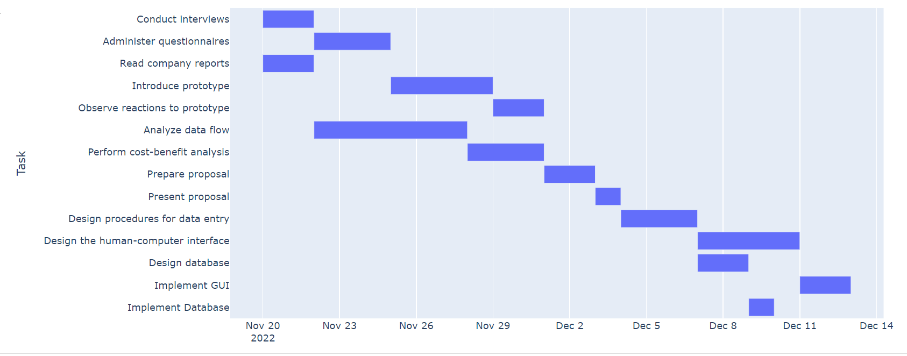

Figure 2 : PERT diagram

Figure : GANTT Chart

## **2.8 Monitoring and Controlling Mechanisms (EVM and Schedule Expediting)**

|  |  |  |  |
| --- | --- | --- | --- |
| Cost/Day  ($) | Crash Time | Estimated Duration | Activity |
| 800 | 1 | 2 | T1 |
| 500 | 1 | 3 | T2 |
| 400 | 2 | 2 | T3 |
| 1000 | 2 | 4 | T4 |
| 1000 | 1 | 2 | T5 |
| 800 | 4 | 6 | T6 |
| 700 | 1 | 2 | T7 |
| 400 | 1 | 2 | T8 |
| 600 | 1 | 1 | T9 |
| 900 | 2 | 3 | T10 |
| 600 | 2 | 4 | T11 |
| 700 | 2 | 2 | T12 |
| 800 | 2 | 2 | T13 |
| 1000 | 1 | 1 | T14 |

Table 2 :Schedule Expediting

|  |  |  |  |  |
| --- | --- | --- | --- | --- |
| Cumulative  Cost ($) | Cost  ($) | Time for Each Path  26 25 23 23 23 22 | Activity  chosen | Eligible  Activates |
| 400 | 400 | 25 24 22 22 22 21 | T8 | T1, T2, T6, T7, T8, T10 or T11 |
| 900 | 500 | 24 23 21 21 22 21 | T2 | T1, T2, T6, T7, T10 or T11 |
| 1400 | 500 | 23 22 20 20 22 21 | T2 | T1, T2, T6, T7, T10 or T11 |
| 2000 | 600 | 22 21 19 19 21 20 | T11 | T1, T6, T7, T10 or T11 |
| 2600 | 600 | 21 20 18 18 20 19 | T11 | T1, T6, T7, T10 or T11 |
| 3200 | 600 | 20 19 17 17 19 18 | T11 | T1, T6, T7, T10 or T11 |
| 3900 | 700 | 19 18 17 17 18 17 | T7 | T1, T6, T7 orT10 |
| 4600 | 800 | 18 17 16 16 18 17 | T1 | T1, T6 orT10 |
| 5400 | 800 | 17 16 16 16 17 16 | T6 | T6 orT10 |
| 6200 | 800 | 16 15 16 16 16 15 | T6 | T6 orT10 |
| Project time was speeded up to end with 16 days instead of 26 days and it was required 6200$ | | | | |

Table 3: : Expediting to require project time

|  |  |  |  |  |  |  |  |
| --- | --- | --- | --- | --- | --- | --- | --- |
| At the end of | Stage | Estimated cost | Cumulative estimate | Estimated duration | Stage completed | Actual cost of stage to date  ($) | Actual cost of project to date  ($) |
| Week 1 | Stage 1 | 5000$ | 5000$ | 1 week | 100% | 5000 | 5000 |
| Week 2 | Stage 2 | 7000$ | 12000$ | 1 week | 100% | 7000 | 12000 |
| Week 3 | Stage 3 | 2000$ | 14000$ | 1 week | 50% | 1000 | 13000 |
| Week 4 | Stage 4 | 1000$ | 15000$ | 1 week | 0% | Not yet begun | Not yet begun |

Table 4:EVM

P = (100 + 100 + 50) / (100 + 100 + 100) = 0.833

EV = PV * P

14000$ * 0.83 = 11662$

In stage 3:

CV = EV – AC

11662$ - 13000 = -1338$

SV = EV – PV

11662$ - 14000 = - 2338$

CPI = EV / AC

11662$ / 13000 = 0.897

SPI = EV / PV

11662$ / 14000 = 0.833

ETC = (BAC – EV) / CPI

(1500$ - 11662$) / 0.897= 3721.29

EAC = AC + ETC

14000 + 3721.29= 17721.29

## **2.9 Risk Analysis and Plans (use Fishbone diagram)**

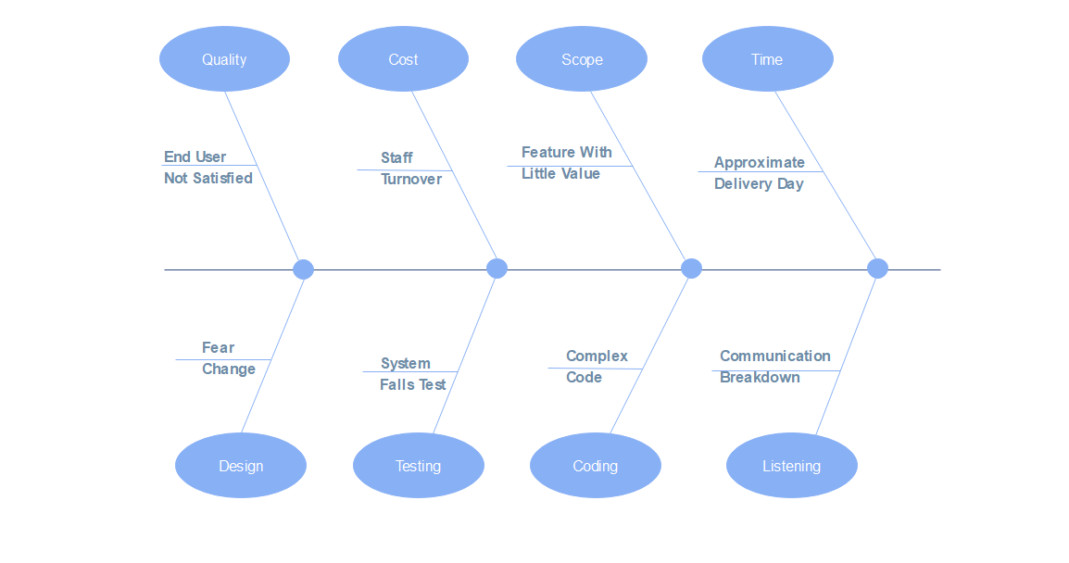

Figure : Fishbone

## **2.10 Local and Global Impact of the Proposed Solution**

A local impact at the level of the university of Jordan and Jordan University Hospital, and the system may be sold to be used in other universities.

# ***3.0 Feasibility Study***

## **3.1 Technical Feasibility**

Laboratory track system website is easy to develop, to maintain and to be updated by our staff in a way that meets the possible requests ever. The software and hardware needed for the development already exists and can benefit from existing tools.

## **3.2 Operational Feasibility**

Laboratory track is operationally, well proposed feasible system that solves the problem patients face. The front-end content and design layouts on the website are straightforward and friendly to use to make patients and anyone else using the website satisfied with the system.

## **3.3 Economic Feasibility**

**Development costs**

* **Personnel:**

|  |  |  |  |  |
| --- | --- | --- | --- | --- |
| Number | Employee | Cost per hour ($) | Total hour | Total cost per hour ($) |
| 4 | System Analysts | 40 | 480 | 19200 |
| 3 | designer | 40 | 120 | 4800 |
| 4 | programmer | 50 | 240 | 12000 |
| 2 | HCI specialist | 25 | 96 | 2400 |
| 1 | Database Specialist | 25 | 24 | 600 |
|  | **Total** |  |  | 39000 |

Table 5: Personnel Development Costs

* + **Expenses:**

|  |  |  |  |
| --- | --- | --- | --- |
| 4 | Smalltalk Training registration | (1250$ /trainer) | 5000 $ |

Table 6 : Expense Development Costs

* + **Hardware and Software:**

|  |  |  |
| --- | --- | --- |
| Number | Hardware & software | Cost ($) |
| 1 | Cloud services | 1500/month |
| 1 | hardware | 800 |
| 1 | DBMS server software | 2500 |
| Total |  | 4800/month |

Table 7: Hardware and Software Development Costs

**Total Development Cost:** 38504$

**Human resources:** developer, programmer, software testing and analysts

* + **Operating Costs:**

|  |  |
| --- | --- |
| hosting serves | 100$ |
| Software maintenance | 1000$ |
| software testing | 1000$ |
| programmer | 1500$ |
| total | 3600$ |

Table 8 :Cost-benefit Analysis - Hardware and Software Operating Costs

* + **Tangible Benefits:** year (1-3)

|  |  |
| --- | --- |
| Tangible Benefits (1-3) Years | Cost ($) |
| Cost avoidance | 4000 |
| Cost reduction (like transportation cost & paper reduction) | 6000 |
| Total | **10000** |

Table 9: Project Tangible Benefits

* + **Intangible Benefits:**
  + Good reputation and image.
  + User satisfaction.
  + Users recommending others to use the website.
  + Time efficiency.
  + **Payback Analysis:**

|  |  |  |  |
| --- | --- | --- | --- |
| Time | Development Cost | Operating Cost($) | Total |
| Year 0 | 28704 | 0 | 28704 |
| Year 1 | 0 | 3600 | 3600 |
| Year 2 | 0 | 3790 | 3790 |
| Year 3 | 0 | 4000 | 4000 |

Table 10: Total of Development and Operating Cost

|  |  |  |  |  |  |  |
| --- | --- | --- | --- | --- | --- | --- |
| Year | Cost | Benefits | Discount Factor  Discount Rate (10%) | Accumulated cost | Accumulated Benefits | NPV  Total |
| Year 0 | 28704 | 0 | 1 | 28704 | 0 | -28704 |
| Year 1 | 3600 | **10000** | 0.9 | 32304 | 9000 | -23304 |
| Year 2 | 3790 | 20200 | 0.82 | 36094 | 16564 | -19530 |
| Year 3 | 4000 | 90000 | 0.75 | 40049 | 67500 | 27451 |

Table 11:Payback Analysis

Since the present value of accumulated benefits in the third year of operation (67500) exceeds the present value of the accumulated costs (40049), this project has payback period of slightly less than three (3) years.

* **Payback Year =** The third Year
* **Lifetime ROI** = (estimated lifetime benefits - estimated lifetime costs) / estimated lifetime cost

= (120200 –40094) /40094

= 1.997954

* **Annual ROI** = Lifetime ROI / Lifetime of The System

= 1.997954/3

= 0.66598

* **Net Present Value =** Total Present value of benefits – Total Present value of costs

= 67500 - 40049 = 27451

## **3.4 Schedule Feasibility**

*** has done in point 2.6&2.7

## **3.5 Legal Feasibility**

This project is legally feasible, as the main issues of the project are within the applicable legal framework.

# ***4.0 Software Requirements Specifications (SRS)***

## **4.1 System Stakeholders and Requirements Sources**

|  |  |
| --- | --- |
| Description | Stakeholder |
| Save the student's medical history, send a medical referral to Blood Laboratory. | Student clinic |
| Enter the Blood test results | Blood Laboratory |
| Is the end-user of our system; Any students or the doctors who wants to access e-service | User |
| Update, maintain and develop programs for the system | System Developer |

Table 12:Stakeholders

Requirements sources are students, student clinic and Blood Laboratory

## **4.2 Information Gathering Techniques**

Questionnaire

We asked students if they have ever benefited from the student clinic, and if they are faced any problems with it, so we suggested If There is ‏system includes solutions for all the problems, they are going to use it.

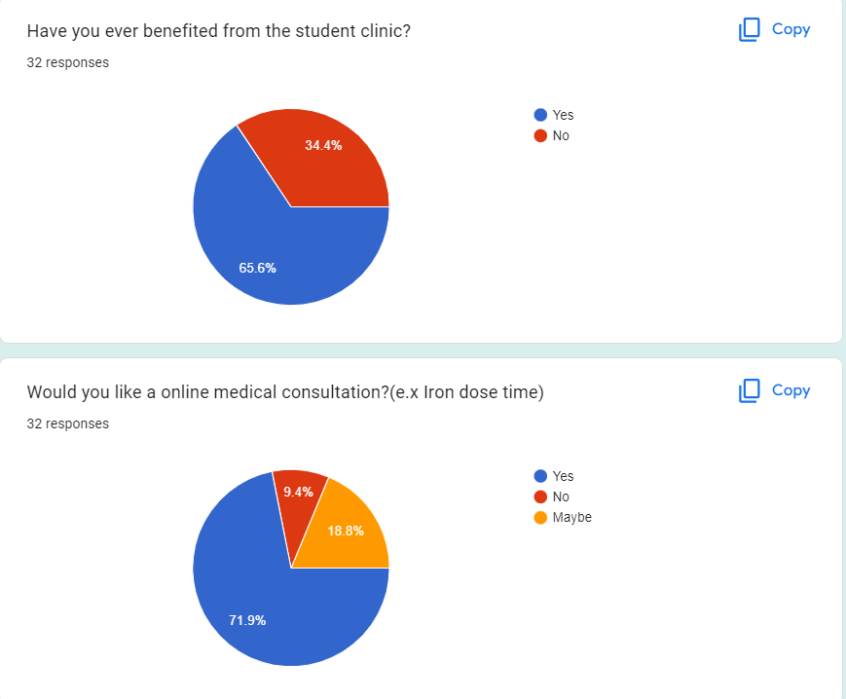

Figure : Questionnaire1

Figure :Questionnaire2

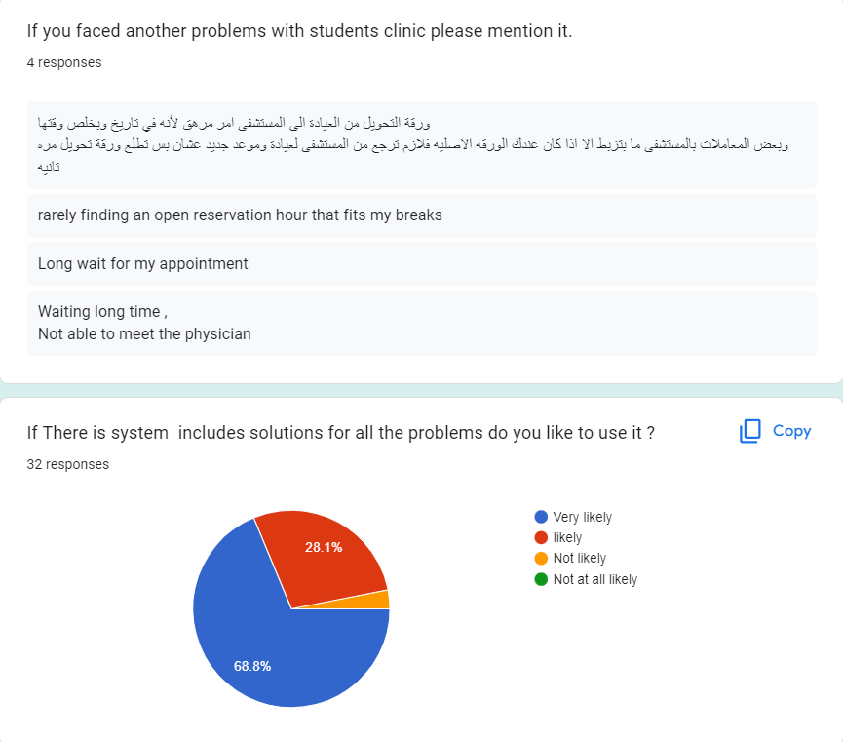

Figure : Questionnaire3

**Interviews**

To increase our information about how the system is supposed to work and how it works currently, we interviewed a medical Doctor, the student clinic's secretary, as well as we interviewed who is responsible about blood test result in the hospital laboratory. After reviewing the whole idea of the system for them and showing the main objectives, these were the answers we got from them:

**Q1)** What is your opinion of having a platform that allows communication between physicians and the patients students? (Question for the doctor)

I think this useful and saving doctors and student time.

**Q2)** Do you think that online services for rescheduling appointments and medical referrals is important and effective? (Question for the student clinic's secretary)

Yes, Save the time of students and Secretary and medical staff even the other patients, so its Provide flexibility, and time management.

**Q3)** Can you allow the students to access the hospital system to be able to view the lab results and medical reports? (Question for IT management Staff)

Yes, I could do that if I got an approval from hospital administration and medical director.

## **4.2 User Requirement Definition (draw context and use case diagrams)**

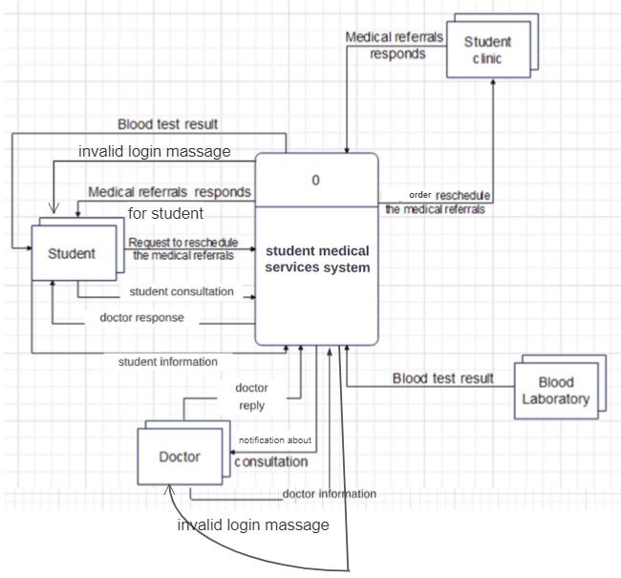

Figure 7: context diagram

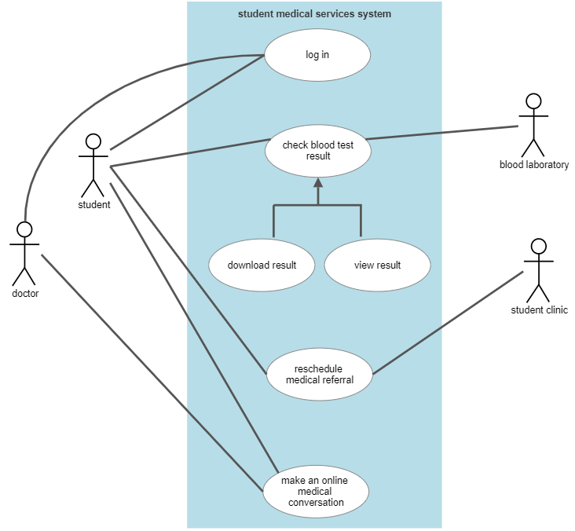

Figure 8: use case diagram

## **4.3 System Functional Requirement Specifications**

|  |  |  |
| --- | --- | --- |
| Description | functional  requirements | Requirement. No |
| Student: Log in to the system by the university account  Doctor: Log in to the system by the university account | Log in | 1 |
| Student: can see the test blood result, new medical referral data | Display/view Data | 2 |
| Blood Laboratory: upload the test blood result | Upload | 3 |
| Student: Doctor consultation  Doctor: Doctor's response | Chat | 4 |
| Developer: Make some changes on the system automated results if its needed. Maintain and upgrade the system. | Improvement | 5 |

## **4.4 Non-Functional Requirements**

|  |  |  |
| --- | --- | --- |
| Description | Non-functional  requirements | Requirement. No |
| Stake holders can use it in any time once there is an internet connection and a device. | Availability | 1 |
| Clear and understandable buttons, fewer steps, and an easy and simple design | User friendly | 2 |
| Only registered students and doctors, Student clinic and Blood Laboratory have access to view info and do  actions. | Security | 3 |
| Each student can see only his/her into. All conversions are private | Privacy | 4 |
| Keeping data contents and structures safe, especially when there are failures. | Integrity | 5 |
| It works only on the extent of its functions and when requested. | Reliability | 6 |
| The number of records or data quantities are all factors to consider and can be managed by universities servers. | Capacity | 7 |
| Producing or operating the sort with the least amount of time, effort, or biases. | Efficiency | 8 |
| It must be utilized by many students and with a large amount of data. | Scalability | 9 |
| the system should be able to endure as many errors and defects as feasible without failing. | Robustness | 10 |

## **4.5 Data Requirements**

1. Only University of Jordan students are allowed to use the system (an active university number).
2. Doctors who will use the system must be university employees.
3. The system requires saving files of blood test results in the database, in addition to medical referrals to the University of Jordan Hospital for each student
4. You need to take part of the data base from the University of Jordan to deal with student data and their university accounts

# ***5.0 System Analysis***

## **5.1 DFDs (at least level 1 DFD)**

Figure 9: DFD

## **5.2 Data Dictionaries**

|  |  |
| --- | --- |
| ID | DF1 |
| Label | Student information |
| Name | Log in |
| Description | Contains student information and it’s used to enter to the student clinic system. |
| Source | Student External Entity |
| Destination | Process 1, log in validation |
| Type | Record Entering |
| Data Structure | student information |
| Volume/Time | 1/life time |

Table 13: data flow1

|  |  |
| --- | --- |
| ID | DF2 |
| Label | Requests to reschedule the medical referrals |
| Name | Medical referrals |
| Description | Request order to student clinic to reschedule the medical referrals |
| Source | Student External Entity |
| Destination | Process 2, reschedule medical referrals |
| Type | Record Entering |
| Data Structure | student information |
| Volume/Time | 1/life time |

Table 14: DFD 2

|  |  |
| --- | --- |
| ID | DF3 |
| Label | order get blood test results |
| Name | Display data |
| Description | The student requests the results of his or her blood tests |
| Source | Student External Entity |
| Destination | Process 4, view test result |
| Type | Record Entering |
| Data Structure | student information |
| Volume/Time | 1/life time |

Table 15: DFD3

|  |  |
| --- | --- |
| ID | DF4 |
| Label | student consultation |
| Name | chatting |
| Description | Conversation between the student and his doctor from the clinic, for possible medical consultation and follow-up |
| Source | Student External Entity |
| Destination | Process 3, chatting |
| Type | Record Entering |
| Data Structure | student information and doctor consultation |
| Volume/Time | Any time |

Table 16: DFD4

|  |  |
| --- | --- |
| ID | DF5 |
| Label | order reschedule the medical referrals |
| Name | Medical referrals |
| Description | Request to extend the medical referrals |
| Source | Process 2, medical referrals |
| Destination | Student clinic External entity |
| Type | Report |
| Data Structure | Approval or rejection |
| Volume/Time | 1/lifetime |

Table 17: DFD 5

|  |  |
| --- | --- |
| ID | DF6 |
| Label | Doctor replay |
| Name | chatting |
| Description | Conversation between the student and his doctor from the clinic, for possible medical consultation and follow-up |
| Source | Doctor External Entity |
| Destination | Process 3, chatting |
| Type | Record Entering |
| Volume/Time | Any time |

Table 18: DFD6

|  |  |
| --- | --- |
| ID | DF7 |
| Label | Blood test results |
| Name | Test results |
| Description | Blood testing laboratories upload and store the results for each student |
| Source | Blood laboratories External Entity |
| Destination | Process 5, upload test results |
| Type | Reports |
| Data Structure | Test results information |
| Volume/Time | Any time |

Table 19: DFD7

|  |  |
| --- | --- |
| ID | DF8 |
| Label | Medical referrals respond |
| Name | respond |
| Description | Send approval or rejection of the increase in the period of medical referrals |
| Source | Process 2, reschedule medical referrals |
| Destination | student External Entity |
| Type | Approval or rejection |
| Data Structure | Report |
| Volume/Time | 1/lifetime |

Table 20: DFD 8

|  |  |
| --- | --- |
| ID | DF9 |
| Label | Medical referrals respond |
| Name | respond |
| Description | Send approval or rejection of the increase in the period of medical referrals |
| Source | Student clinic External Entity |
| Destination | Process 2, reschedule medical referrals |
| Type | Approval or rejection |
| Data Structure | Report |
| Volume/Time | 1/lifetime |

Table 21: DFD9

|  |  |
| --- | --- |
| ID | DF10 |
| Label | Doctor responds |
| Name | chatting |
| Description | The doctor's response to the student |
| Source | Process 3, chatting |
| Destination | student External Entity |
| Type | Conversation |
| Data Structure | Doctor consultation |
| Volume/Time | Any time |

Table 22: DFD10

|  |  |
| --- | --- |
| ID | DF11 |
| Label | Blood test results |
| Name | Display data |
| Description | The required student examination results appear |
| Source | Process 4, view test results |
| Destination | Student External Entity |
| Type | Report |
| Data Structure | Test results information |
| Volume/Time | - |

Table 23: DFD11

|  |  |
| --- | --- |
| ID | DF12 |
| Label | Notification about consultation |
| Name | chatting |
| Description | Alert that there is a message from the student to conduct the conversation |
| Source | Process 3, chatting |
| Destination | Doctor External Entity |
| Type | Alert/ notification |
| Data Structure | Short message |
| Volume/Time | Any time |

Table 24:DFD12

|  |  |
| --- | --- |
| ID | DF13 |
| Label | Confirm |
| Name | Confirm |
| Description | Log in correctly |
| Source | Process 1, log in validation |
| Destination | Process 3, chatting |
| Type | Internal |
| Data Structure | Enter system |
| Volume/Time | --- |

Table 25:DFD13

|  |  |
| --- | --- |
| ID | DF14 |
| Label | Confirm |
| Name | Confirm |
| Description | Log in correctly |
| Source | Process 1, log in validation |
| Destination | Process 2, reschedule medical referrals |
| Type | Internal |
| Data Structure | Enter system |
| Volume/Time | --- |

Table 26: DFD14

|  |  |
| --- | --- |
| ID | DF15 |
| Label | Confirm |
| Name | Confirm |
| Description | Log in correctly |
| Source | Process 1, log in validation |
| Destination | Process 4, view test results |
| Type | Internal |
| Data Structure | Enter system |
| Volume/Time | --- |

Table 27: DFD15

|  |  |
| --- | --- |
| ID | DF16 |
| Label | The blood test results |
| Name | Results |
| Description | It includes fetching the results from their saved location and displaying them upon request |
| Source | Data store, test blood results |
| Destination | Process 4, view test results |
| Type | report |
| Data Structure | information |
| Volume/Time | .. |

Table 28:DFD 16

|  |  |
| --- | --- |
| ID | DF17 |
| Label | Clint data |
| Name | data |
| Description | Information about who enter system |
| Source | Data store, log in information |
| Destination | Process 1, log in validation |
| Type | record entering |
| Data Structure | data |
| Volume/Time | -- |

Table 29: DFD 17

|  |  |
| --- | --- |
| ID | DF18 |
| Label | Store results |
| Name | storing |
| Description | Store results from the laboratory after uploading them to the system |
| Source | Process 5, upload test blood results |
| Destination | Data store, test blood results |
| Type | Report |
| Data Structure | information |
| Volume/Time | --- |

Table 30: DFD 18

|  |  |
| --- | --- |
| ID | DF19 |
| Label | Doctor information |
| Name | Log in |
| Description | Contains doctor information and it’s used to enter to the student clinic system. |
| Source | doctor External Entity |
| Destination | Process 1, log in validation |
| Type | Record Entering |
| Data Structure | student information |
| Volume/Time | 1/lifetime |

Table 31: DFD19

|  |  |
| --- | --- |
| ID | DF20 |
| Label | Invalid log in message |
| Name | Log in message |
| Description | A message to the student in case the data does not match and the inability to enter the system |
| Source | Process 1, log in validation |
| Destination | Student external entity |
| Type | Record Entering |
| Data Structure | information |
| Volume/Time | --- |

Table 32: DFD 20

|  |  |
| --- | --- |
| ID | DF21 |
| Label | Invalid log in message |
| Name | Log in message |
| Description | A message to the student in case the data does not match and the inability to enter the system |
| Source | Process 1, log in validation |
| Destination | Doctor external entity |
| Type | Record Entering |
| Data Structure | information |
| Volume/Time | --- |

Table 33: DFD 21

**Data structure:**

student information =

student Name +

student university number +

The date of the clinic visit

Doctor information = Doctor university number +

The date of student clinic visit +

The date of student test blood

**Structural records:**

student university number = student id

student Name = first name + (middle name) + last name

The date of the clinic visit = day + month + year

The date of test blood = = day + month + year

**Element:**

|  |  |  |
| --- | --- | --- |
| Element | Length | Data Type |
| First Name | 12 | Text |
| Last Name | 15 | Text |
| Email | 20 | varchar |
| id | 7 | int |
| Date | 20 | varchar |

Table 34:element

**Data element:**

|  |  |
| --- | --- |
| ID | E1 |
| Name | Student university Number |
| Alias | Student ID |
| Alias | Id_no. |
| Description | University student number |
| Length | 7 |
| Input format | 9(7) |
| output format | 9(7) |
| Default value |  |
| Continues / Discrete | Continues |
| Type | Int |
| Base or derived | Base |
| Upper Limit | 7 |
| Lower Limit |  |
| Discreet | Meaning |

Table 35: data element

**Data store:**

|  |  |
| --- | --- |
| ID | D1 |
| Name | Test blood result |
| Alias | Test results Database |
| Description | It includes all the tests that the student conducted in the blood test laboratory, so that the results are downloaded/stored on an up-to-date basis |
| File type | computer |
| File format | Database |
| Record size | 100 |
| Maximum records | 45,000 |
| Average records | 40,000 |
| Percent Growth/year | 14% |
| Data set/Table name | student |
| Copy member | student |
| Data Structure | student Information |
| Primary key | Student university Number |

Table 36: data store1

|  |  |
| --- | --- |
| ID | D2 |
| Name | Log in information |
| Alias | Log in - Database |
| Description | It includes all the information entered by the student, through which the doctor can access the rest of his information |
| File type | Computer |
| File format | Database |
| Record size | 100 |
| Maximum records | 45,000 |
| Average records | 40,000 |
| Percent Growth/year | 14% |
| Data set/Table name | student |
| Copy member | student |
| Data Structure | student Information |
| Primary key | Student university Number |
| Secondary key | Student university email |

Table 37: data store 2

## **5.3 Process Specification and Structured Decision Analysis**

Log-in (return-confirm-or-deny, doctor-information, student-information) invalid-log-in, confirm

IF student and doctor student-information, return-confirm-or-deny, doctor-information are available

PRODUCE confirms

Else GENERATE invalid-log-in to both student and to the doctor;

Upload-test-results(blood-test-result) store-results

If blood tests results blood-test-result from the Blood Laboratory

are ready and available

then PRODUCE store-results to the test blood results;

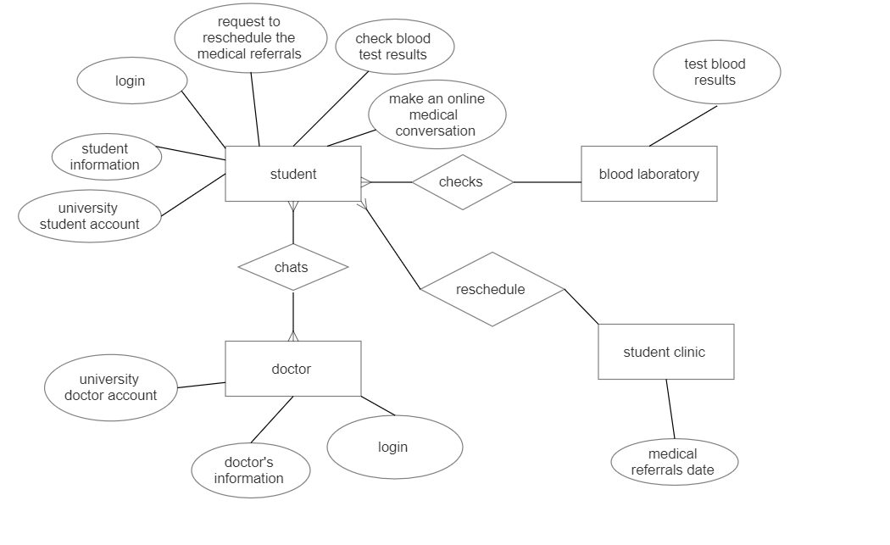

reschedule-Medical-referrals (request-to-reschedule-the-medical-referrals,medical-referrals-responds ,confirm)medical-referrals-responds-to-the-student,requested-order-reschedule

If the student confirms and request-to-reschedule-the-medical-referrals

then PRODUCE request-to- reschedule-the-medical-referrals,

and if medicals-referrals-responds came from the student clinic

then GENERATE medical-referrals-responds-to-the-student;

chatting(student-consultation ,doctor-replay)notification-about-consultation ,doctor-responds

If the student student- consultation wanted

to chat with a specific doctor

then GENERATE notification-about-consultation to the doctor ,

and if the doctor doctor-replay responded

then PRODUCE doctor-responds and send it to the student ;

View-test-results(the-blood-test-results, order-to-get-blood-test-result, confirm)blood-test-result

If the student who is confirmed from the log in confirm and the student order-to-get-blood-test-result asked to view the results and the results the-blood-test-results was uploaded

then PRODUCE blood-test-result to the student;

chatting(student-consultation ,doctor-replay)notification-about-consultation ,doctor-responds

If the student student-consultation wanted

to chat with a specific doctor

then GENERATE notification-about-consultation to the doctor,

and if the doctor doctor-replay responded

then PRODUCE doctor-responds and send it to the student;



* **If students information is not available:**

Can’t log in

* **If Doctor’s information is not available:**

Can’t log in

* **If there is no medical referrals in the Student clinic**

Student can’t reschedule

* **If Blood Laboratory don’t have the result ready**

Student can’t download or view the result

## 

## **5.4 ERD analysis**

Figure : ERD

# ***6.0 System Design***

## **6.1 Architecture Design**



Student

Doctor

Log in interface

Student page

Blood test result

Medical referral

Online consultation



database

database



Student clinic

Blood Laboratory

## **6.2 Graphical User Interface Design (input and output design including forms and reports)**

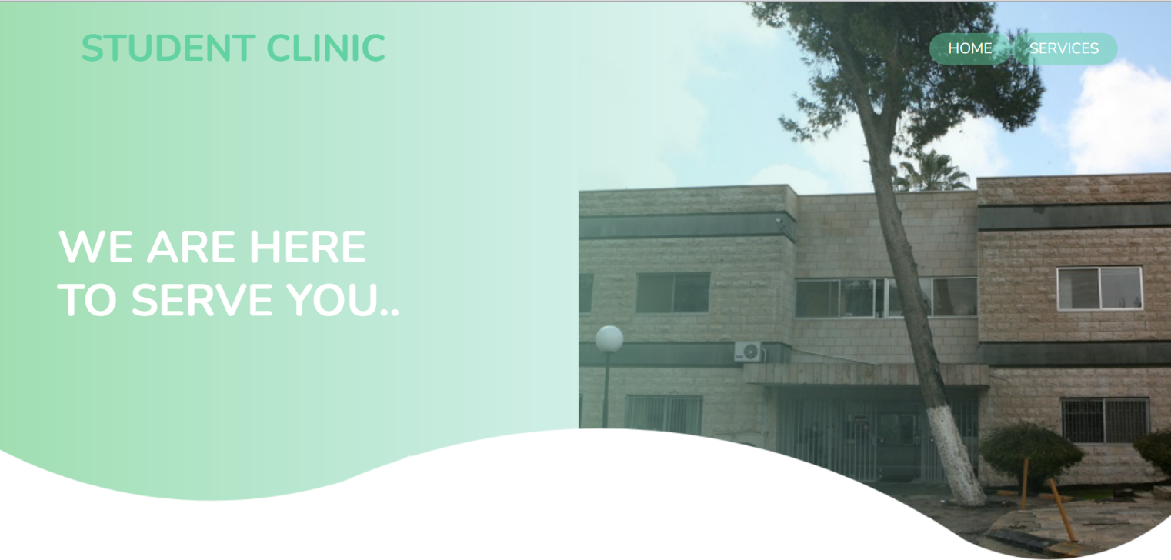

## **6.3 Database Design (DB normalization)**

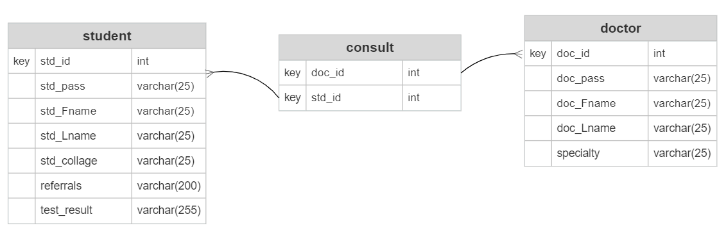

Figure 13: database design

# ***7.0 Implementation***

## **7.1 Graphical User Interface Implementation (Required)**

<https://github.com/Moniadahnoon/SystemProject>

# 8.0 User Manual

**If you want to login as a doctor**

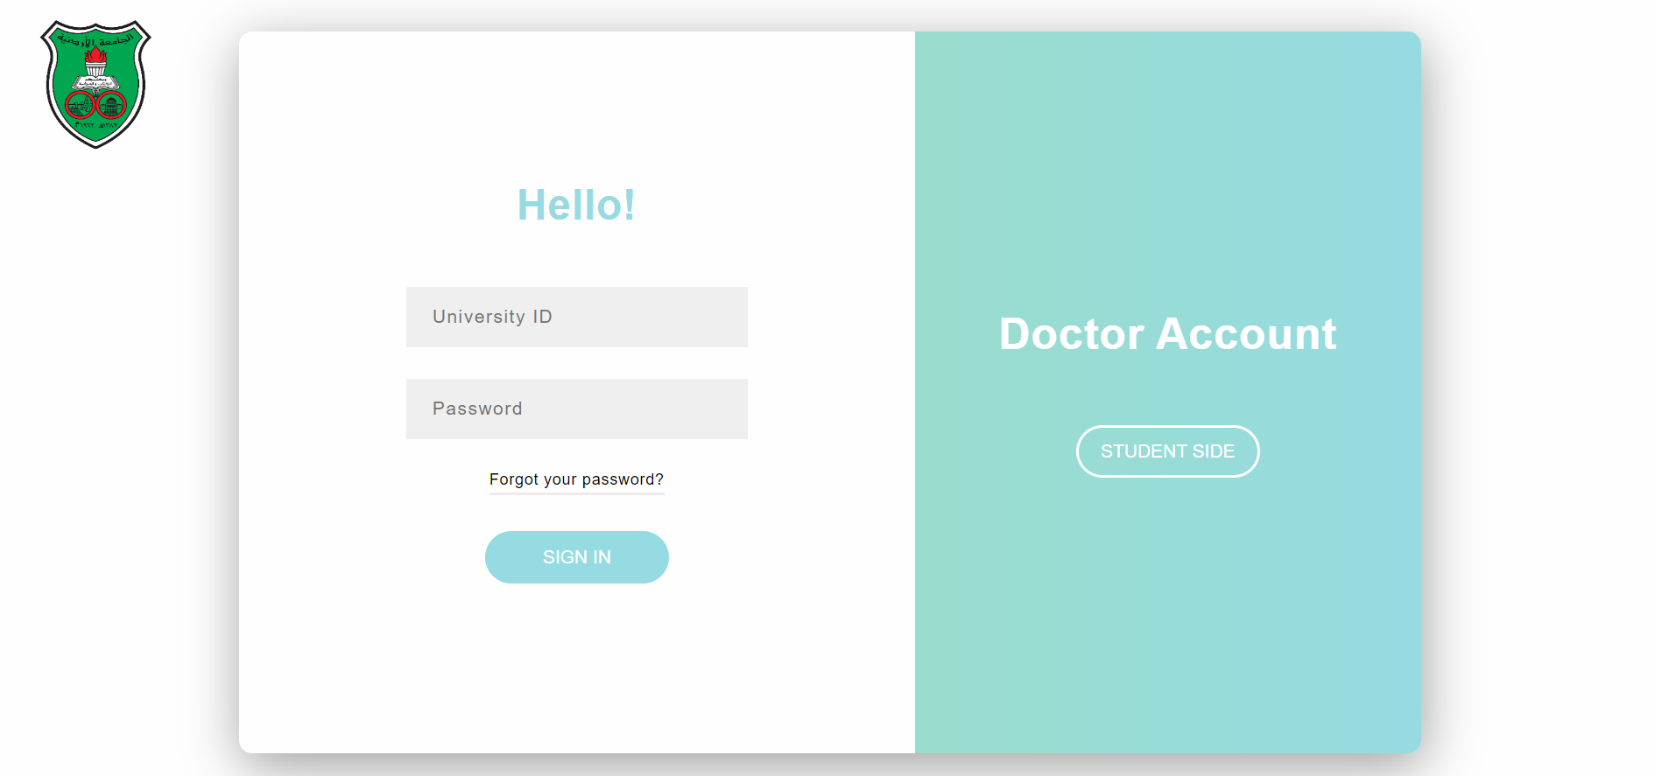

**If you want to login as a student**

**If you are a student:**

**Click here to check Click here if you wont to Extension Click here for a medical**

**your blood test result of the medical referral date consultation from a specialist**

# **9.0 References: books and tools**

* <https://www.smartdraw.com/entity-relationship-diagram/er-diagram-tool.htm>
* [https://lucid.app/lucidchart/af9e46e0-638e-4fd4-bf27-615f2241896f/edit?invitationId=inv_cd8e243e-c352-43e1-8176-ec572a6a578e&page=0_0#](https://lucid.app/lucidchart/af9e46e0-638e-4fd4-bf27-615f2241896f/edit?invitationId=inv_cd8e243e-c352-43e1-8176-ec572a6a578e&page=0_0)
* <https://learn.microsoft.com/en-us/sql/t-sql/data-types/int-bigint-smallint-and-tinyint-transact-sql?view=sql-server-ver16>
* https://www.drupal.org/docs/7/api/schema-api/data-types
* <https://lucid.app/documents#/dashboard?folder_id=home>
* <https://www.youtube.com/watch?v=zid-MVo7M-E>
* <https://online.visual-paradigm.com/diagrams/features/dfd-maker/>